Activity 2: UML Diagram Design Project

- Project Title
- Based POS and Inventory Management System for Sio Republic – Hinunangan Branch
- Brief System Description

Sio Republic Hinunangan Branch is a small food business that sells pork siomai, chicken siomai, and red iced tea. Currently, the business uses manual recording for sales and inventory, which may lead to errors, inaccurate computations, and difficulty in tracking stock levels and daily income.
This system proposes a POS-based Sales and Inventory Management System that automates the process of recording sales, updating inventory, and generating reports. The system allows staff to process transactions efficiently while enabling the admin to monitor stock and sales performance in real time.

- Actors / Users
• Admin
• Cashier / Staff

- Main System Functions

Admin:
• Login
• Manage Products
• Manage Inventory
• View Sales Reports
• Manage Users

Staff:
• Login
• Process Sale
• Print Receipt
• View Products

Customer:
• Place order
• View order status
• Provide delivery details

- UML Diagram (Use Case Diagram)

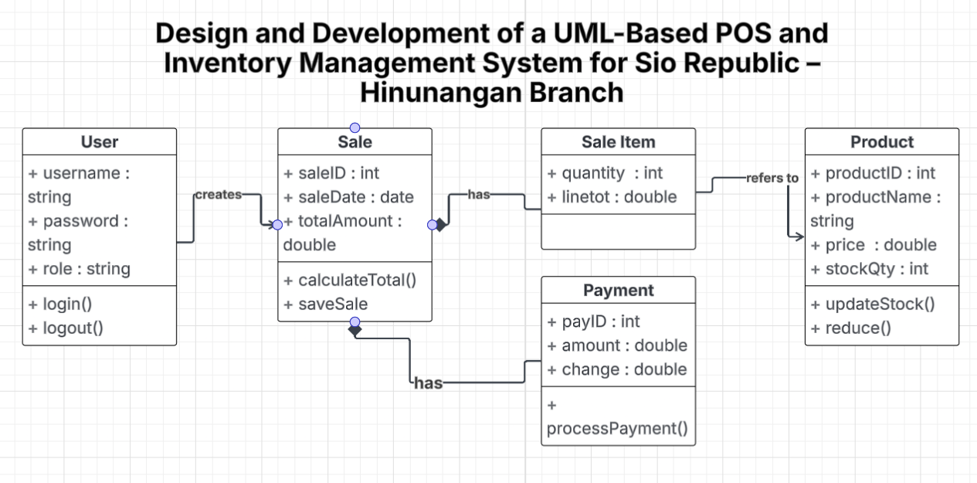

Short Explanation
The UML diagram represents a POS-based Sales and Inventory System for Sio Republic. It shows how users interact with the system to manage sales, products, and inventory. The Admin handles system management and reporting, while the Staff processes sales transactions. The system improves accuracy, efficiency, and organization of business operations. It also ensures proper tracking of inventory and sales data.

